**Karan Arora**  **R.L. Institute M: 9416974837**

**Max Time : 3 hr** **Class : 12th Chemistry Max Marks : 70**

**Full Syllabus Test**

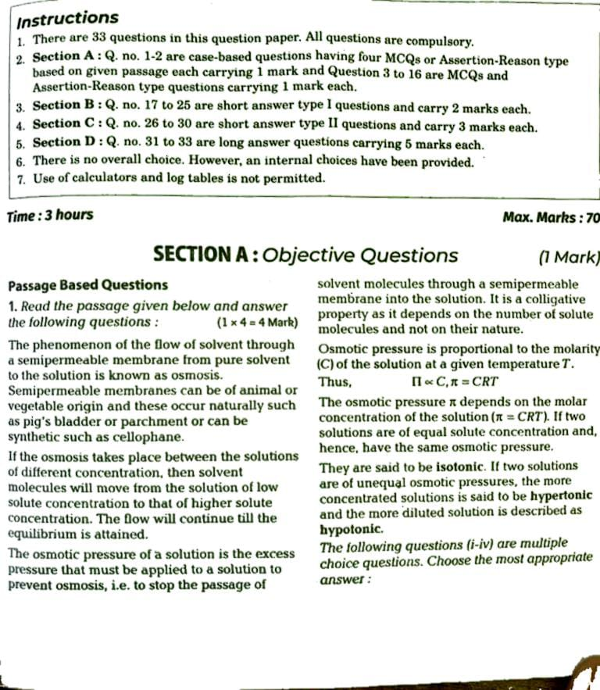

1. h
2. h

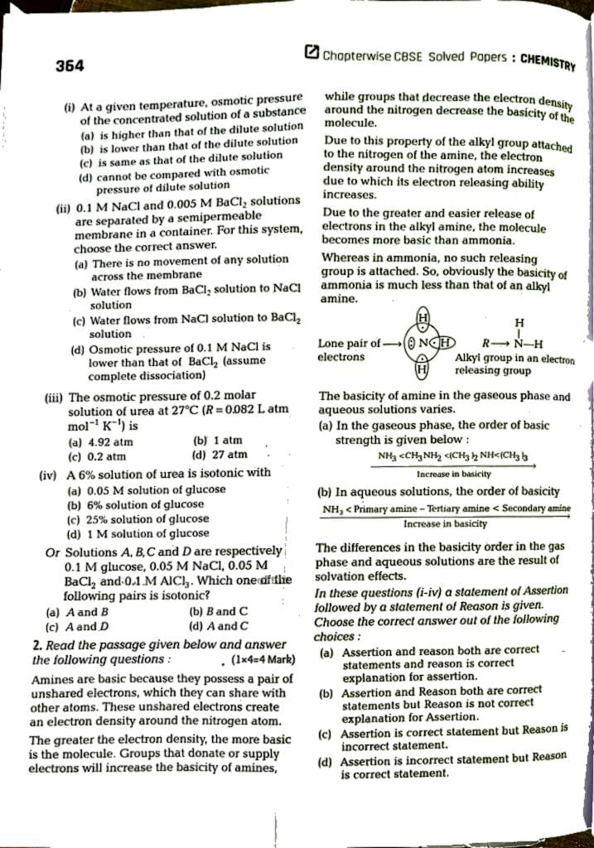

1. **Assertion:** Order of basicity of amines in gaseous phase is NH3 > primary amine > secondary amine > tertiary amine

**Reason:** In gaseous phase, the basic nature aliphatic amine increases with the increase in number of alkyl groups.

1. **Assertion:** Aliphatic amines are weaker bases than ammonia and aromatic amines are stronger bases than ammonia.

**Reason:** + I effect of alkyl groups in aliphatic amines increases the electron density on nitrogen atom. Aromatic amines are weaker due to electron withdrawing nature of the aryl group.

1. **Assertion:** MeNH2 is the weaker base than MeOH.

**Reason:** N is less electronegative than O, lone pair of electrons on N is more easily available for the donation in MeNH2

1. **Assertion:** Aniline is a weaker base than cyclohexyl amine.

**Reason:** Aniline undergoes halogenation even in absence of a catalyst.

Or

**Assertion:** Ammonia is less basic than water.

**Reason:** Nitrogen is less electronegative than oxygen.

Multiple choice questions :

1. Considered the following structures :

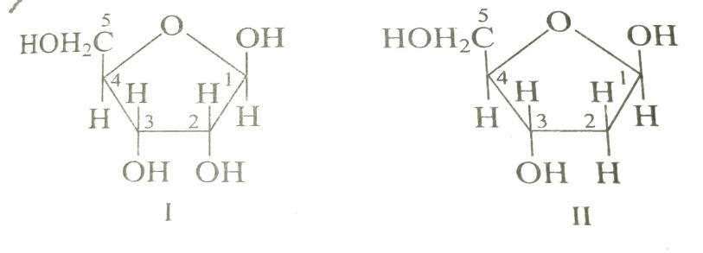

Identify structure I and II and choose the correct option :

|  |  |
| --- | --- |
| a) I = $β$– D – ribose ; II = $β$– D – 2-deoxyribose | b) I = $α$– D – ribose ; II = $β$– D – 3-deoxyribose |
| c) I = $β$– D – deoxyribose ; II = $β$– D – ribose | d) I = $β$– D – deoxyribose ; II = $α$– D – ribose |

1. Some reactions along with the units of their rate constant given below :

|  |  |  |
| --- | --- | --- |
| S. No. | Reaction | Units of rate constant |
| 1 | SO2Cl2 SO2 + Cl2 | s – 1 |
| 2 | NO + O3 NO2 + O2 | L mol – 1 s – 1 |
| 3 | 2 NO + Cl2 2 NOCl | L2 mol – 2 s – 1 |

Which of the following represent a third order reaction :

|  |  |  |  |
| --- | --- | --- | --- |
| a) SO2Cl2 SO2 + Cl2 | b) NO + O3 NO2 + O2 | c) 2 NO + Cl2 2 NOCl | d) none of the above |

1. Among the following which hydrocarbon is not produced by Wurtz reaction?

|  |  |
| --- | --- |
| a) methane | b) ethane |
| c) propane | d) all the given options cannot be prepared |

1. We know that the relationship between Kc and Kp is : KP = Kc .

What would be the value of $∆$ n for the reaction? NH4Cl (s) NH3 (g) + HCl (g)

|  |  |  |  |
| --- | --- | --- | --- |
| a) 1 | b) 0.5 | c) 1.5 | d) 2 |

1. For strong electrolytes, the plot of molar conductance v/s $\sqrt{C}$ is :

|  |  |  |  |
| --- | --- | --- | --- |
| a) parabolic | b) Linear | c) sinusoidal | d) Circular |

1. Which of the following groups increases basic strength of substituted aniline?

|  |  |  |  |
| --- | --- | --- | --- |
| a) – OCH3 | b) – CH3 | c) – SO3H | d) Both (a) & (b) |

1. Among the ligands NH3 , en , CN – and CO, the correct order of their increasing field strength, is :

|  |  |
| --- | --- |
| a) CO < NH3 < en < CN – | b) NH3 < en < CN – < CO |
| c) CN – < NH3 < CO < en | d) en < CN – < NH3 < CO |

1. Heterolyptic complex is :

|  |  |  |  |
| --- | --- | --- | --- |
| a) ${[Fe {(CN)}_{6}]}^{4-}$ | b) ${[Co {\left({NH}_{3}\right)}_{5} {SO}_{4}]}^{+}$ | c) ${[HgI_{6}]}^{2-}$ | d) ${[Co {\left({NH}_{3}\right)}_{6}]}^{3+}$ |

1. The electrophile used in Reimer-Tiemann reaction is :

|  |  |  |  |
| --- | --- | --- | --- |
| a) | b) : CCl2 | c) | d) H2O |

Assertion-Reason :

1. If both assertion and reason are true, but reason is the true explanation of the assertion.
2. If both assertion and reason are true, but reason is not the true explanation of the assertion.
3. If assertion is true, but reason is false.
4. If assertion is false, but reason is true.
5. **Assertion:** The aldehyde group is absent in the pentacetate of D-glucose?

**Reason:** It has ketonic group.

**Or**

**Assertion:** When glucose is treated with HI, it forms hexane.

**Reason:** due to absence of amino acids.

1. **Assertion:** SN1 reaction is accompanied by racemisation.

**Reason:** Carbocation is formed in this reaction and attack of nucleophile can be from either side of leaving group.

1. **Assertion:**  Glucose can be prepared by sucrose

**Reason:**  C12H22O11 + H2O C6H12O6 + C6H12O6

1. **Assertion:** Pure water conducts electricity.

**Reason:** Pure water exists in unionized form.

1. **Assertion:** Ethanol and acetone show positive deviation from Raoult’s law.

**Reason:** Pure ethanol molecule show hydrogen bond and on adding acetone hydrogen bond between ethanol molecules breaks.

**Section – B**

1. Why is the reactivity of all the three classes of alcohols with conc. HCl and ZnCl2 (Lucas reagent) different?

Or

NF3 is an exothermic compound, while NCl3 is not, why?

1. A solution containing 34.2 g of cane sugar dissolved in 500 cm3 of water brought 0.374 K. calculate the freezing point depression constant of water.
2. Ethylamine is soluble in water whereas, aniline is not soluble in water. Explain.
3. Write IUPAC name of the following :

(a) (b) K3 [Fe(CN)6] (c) [Ag (NH3)2] Cl (d) [Pt (NH3)2 Cl2]

Or

Draw the structure of isomers of following complex and write its IUPAC name also: ${[Cr {\left({NH}_{3}\right)}_{4} {Cl}_{2}]}^{+}$

1. Calculate the spin only magnetic moment of M2+ (aq) ion. (Z = 27)

Or

Explain why Cu+ (I) ion is not stable in aqueous solution?

1. Vapour pressure of pure water at 298 K is 23.8 mm of Hg. 50 g of urea is dissolved in 850 g of water. Calculate the vapour pressure of the water for this solution and its relative lowering.
2. The resistance of a conductivity cell containing 0.001 M KCl solution at 298 K is 1500 $Ω$. What is the cell constant if the conductivity is 0.001 M KCl solution at 298 K is 0.146 x 10 – 3 S cm – 1 ?
3. The half-life period of a first order reaction is 60 min. What percentage will be left after 120 minutes?
4. Why are haloarenes more stable than Haloalkanes and undergo electrophilic substitution reaction at o- and p-position?

**Section – C**

1. Explain the following terms :

(i) Linkage isomerism (ii) outer orbital complex (iii) Ambidentate ligand

Or

Write the products A and B in the following :

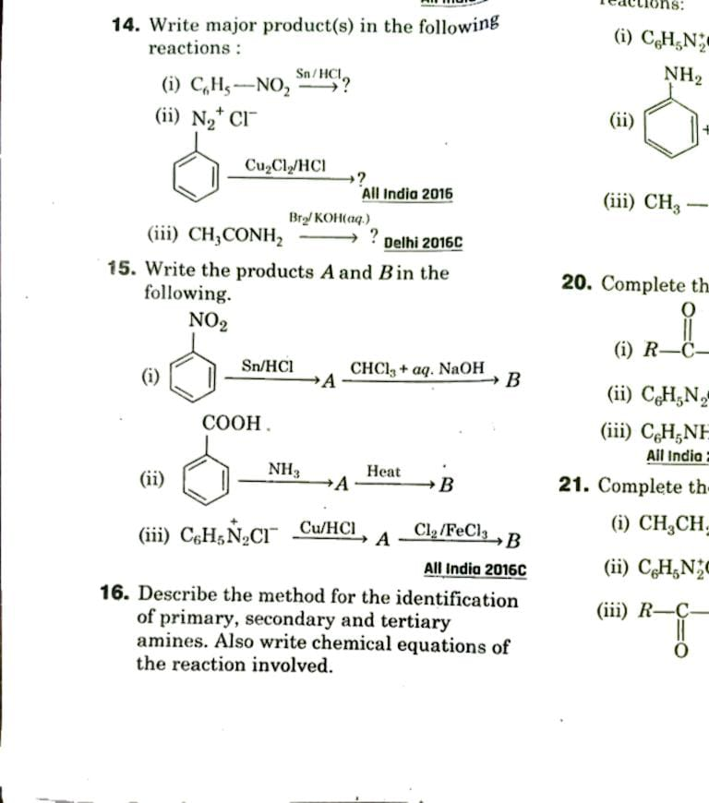

1. Account for the following differences in the acidic character of the following :

a) Me3C – CH2 – COOH > Me­3SiCH2COOH b) H2C CHCH2COOH > CH3CH2COOH

c) N C – CH2 COOH > CH3COCH2COOH

Or

How are the following conversions carried out?

a) Ethyl cyanide to ethanoic acid b) Butan-1-ol to butanoic acid

c) benzoic acid to m-bromobenzoic acid

1. Predict the products of the following reactions.

(i) CH3 – CH CH2 (ii) C6H5OH (iii) CH3CH2COOH

1. Give the reaction of alcohols with Phosphorus trihalides and hydrogen halides.
2. The thermal decomposition of HCOOH is a first order reaction with a rate constant of 2.4 x 10 – 3 s – 1 at a certain temperature. How long will it take for three fourth of initial quantity of HCOOH to decompose?

(Log 0.25 = - 0.6021)

**Section – D**

1. (i) Account of the following :
2. Mn show the highest oxidation state of + 7 with oxygen but with fluorine, it shows the highest oxidation state of + 4.
3. Cr2+ is a strong reducing agent.
4. Cu2+ salts are coloured, while Zn2+ salts are white.

(ii) Complete the following equations:

1. 2MnO2 + 4 KOH + O2 b) + 14 H+ + 6 I –
2. (i) Can you store copper sulphate solution in a zinc pot?

(ii) The molar conductivity od 0.025 mol/L methanoic acid is 46.1 S cm2 mol – 1 , Calculate its degree of dissociation and dissociation constant. Given $λ^{o}$ (H+) = 349.6 S cm2 mol – 1  and (HCOO – 1) = 54.6 S cm2 mol – 1 .

Or

(i) Given the standard electrode potential :

K+/K = -2.93 V , Ag+/Ag = 0.80 V , Hg2+/Hg = 0.79 V , Mg2+/Mg = -2.37 V , Cr3+/Cr = -0.74 V

Arrange these metals in their increasing order of reducing power.

(ii) Conductivity of 2.5 x 10 – 4 M methanoic acid is 5.25 x 10 – 5 S cm – 1. Calculate its molar conductivity and degree of dissociation. Given $λ^{o}$ (H+) = 349.5 S cm2 mol – 1  and (HCOO – 1) = 50.5 S cm2 mol – 1 .

1. The element of 3d transition series given as : Sc Ti V Cr Mn Fe Co Ni Cu Zn

Answer the following :

1. Write the element which shows maximum number of oxidation states. Given reason.
2. Which element has the highest melting point?
3. Which element show only +3 oxidation state?
4. Which element is strong oxidizing agent in +3 oxidation state and why?

Or

1. Describe the following characteristics of the first series of the transition metals and their trends in the series (Sc to Zn). (a) Atomic radii (b) Ionisation enthalpies
2. What may be possible oxidation states of the transition metals with the following d-electronic configurations in the ground state of their atoms 3d3 4s2 , 3d5 4s2 and 3d6 4s2. indicate relative stability of oxidation state in each case.